







UID /contact/

ReadySetResource.com

Contents

8.1 - Company Details 3

8.2 - Solutions 4

8.3 - Payment Method 5

8.4 - UID /home/ Work Log 6

# 10.1 - Why Not Try

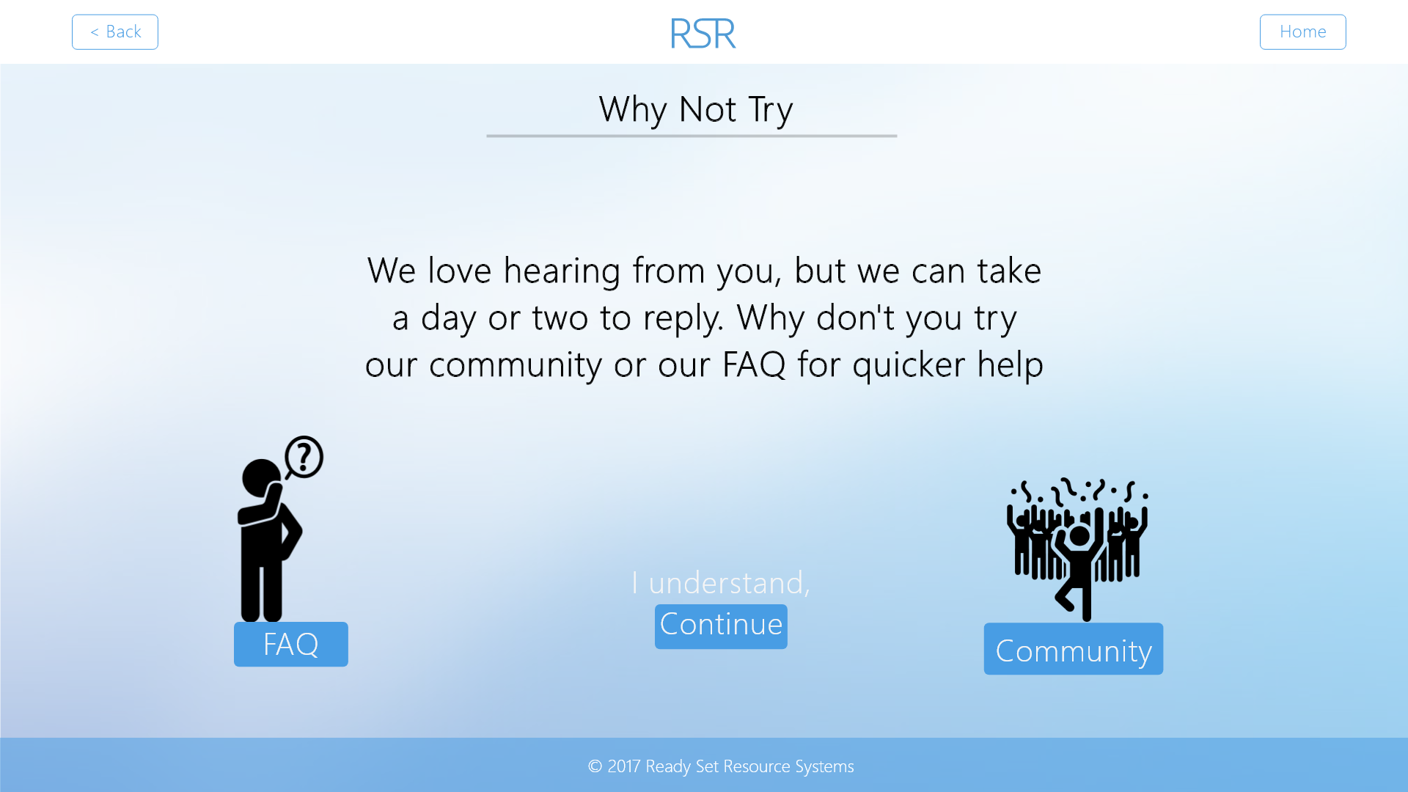

Input Permissible: None

Error Messages: None

# 10.2 - Contact Us

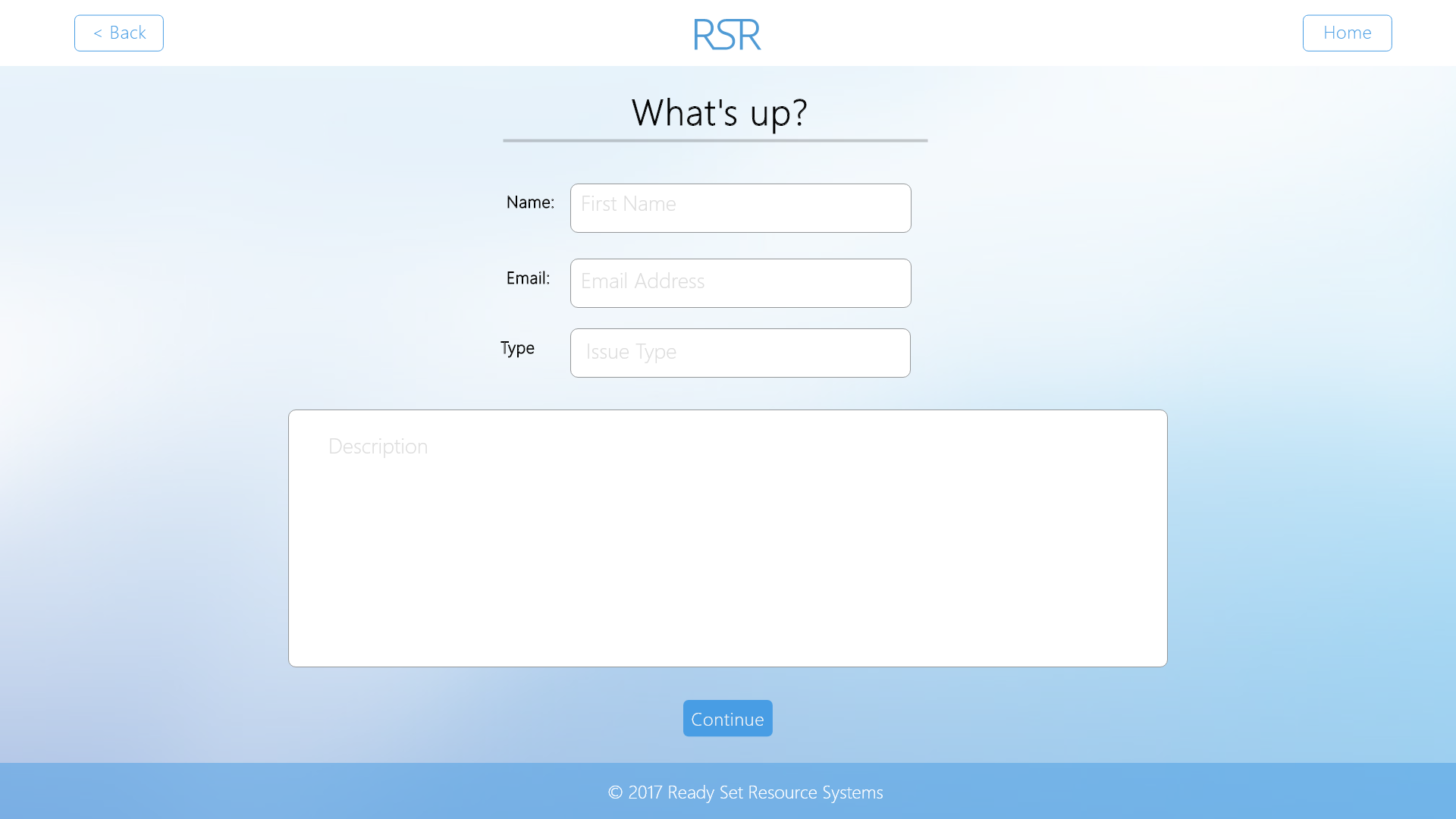

Input Permissible: - Name

- Email

- Issue Type

- Description

Error Messages: - ‘Please complete all fields’

- ‘The field is too long’

# 10.3 - Thank You

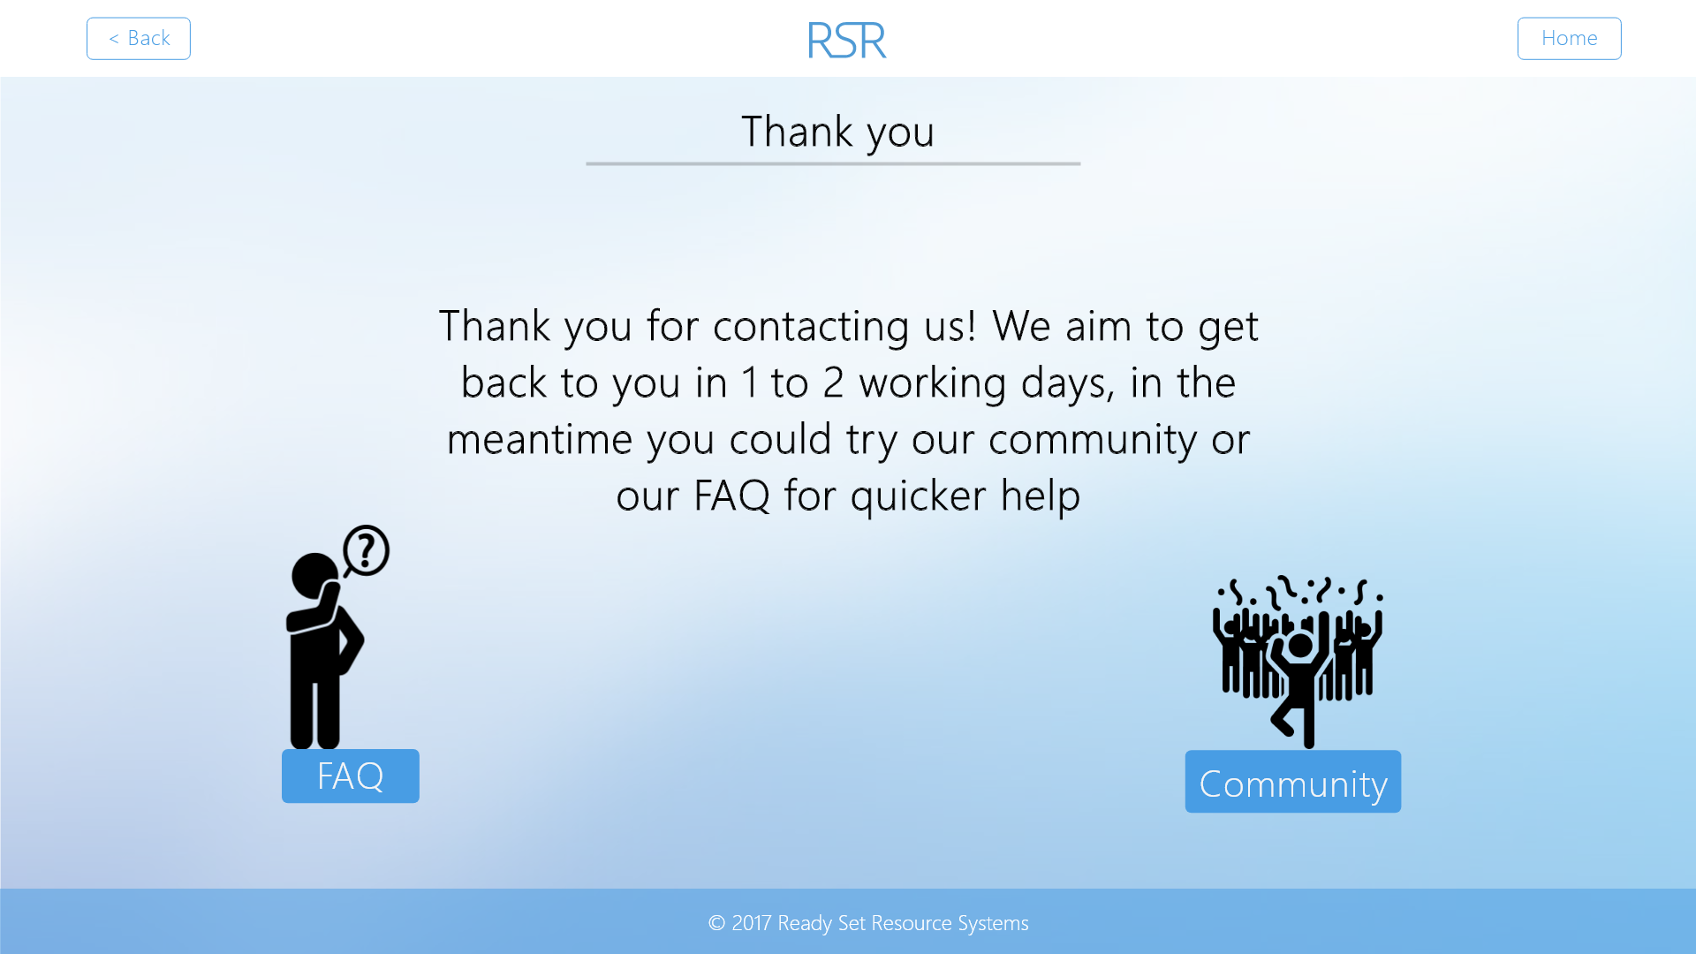

Input Permissible: None

Error Messages: None

# 8.4 - UID /contact/ Work Log

| Entry | Description | Person | Date | Mins Spent |
| --- | --- | --- | --- | --- |
| 1 | Formatted the document | Aidan Marshall | 19/3/18 | 3 |
| 2 | Designed the website | Aidan Marshall | 19/3/18 | 48 |
| 3 | Added screenshots and page details | Aidan Marshall | 19/3/18 | 12 |
| 63 | | | | |